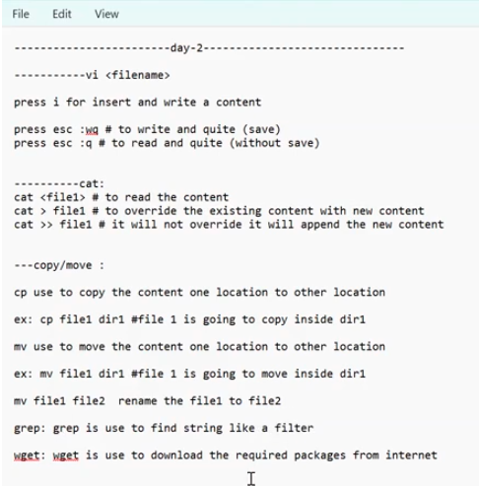

is grep file1 ------to show file1

ls | grep raki ------- to show directory

| stands for pipe symbol